EXP 1 :Develop a Python-based Reinforcement Learning model using the OpenAI Gym environment to solve a Grid World navigation problem where the agent must reach the goal while avoiding obstacles. Explain how the state space, action space, reward function, and constraints are defined.
CODE :
import random
GRID_SIZE = 5
START = (0, 0)
GOAL = (4, 4)
OBSTACLES = [(1, 1), (2, 2), (3, 1)]
ACTIONS = {
0: (-1, 0), # Up
1: (1, 0), # Down
2: (0, -1), # Left
3: (0, 1) # Right
}
state = START
print("Starting Grid World Navigation")
while state != GOAL:
print("Current Position:", state)
action = random.randint(0, 3)
move = ACTIONS[action]
new_row = state[0] + move[0]
new_col = state[1] + move[1]
if new_row < 0 or new_row >= GRID_SIZE or new_col < 0 or new_col >= GRID_SIZE: reward = -5
print("Moved Outside Grid")
print("Reward:", reward)
elif (new_row, new_col) in OBSTACLES:
reward = -10
print("Hit Obstacle")
print("Reward:", reward)
else:
state = (new_row, new_col)
if state == GOAL:
reward = 100
print("Goal Reached")
print("Reward:", reward)
break
else:
reward = -1
print("Moved to:", state)
print("Reward:", reward)
print("Navigation Completed")
OUTPUT :
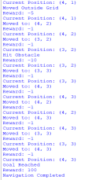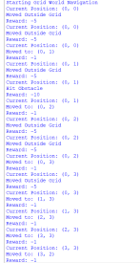
EXP 2 : Implement an ε-greedy Multi-Armed Bandit algorithm in Python to maximize rewards under a limited budget of 500 trials. Compare the effect of different ε values (0.1, 0.3, and 0.5) on exploration, exploitation, and constraint satisfaction.
CODE :
import random
# True reward probabilities for 5 arms
true_rewards = [0.2, 0.4, 0.6, 0.8, 0.5]
trials = 500
epsilons = [0.1, 0.3, 0.5]
for epsilon in epsilons:
estimates = [0] * len(true_rewards) # Estimated rewards
counts = [0] * len(true_rewards) # Number of times each arm is selected total_reward = 0
explore = 0
exploit = 0
for _ in range(trials):
# Exploration or Exploitation
if random.random() < epsilon:
arm = random.randint(0, len(true_rewards) - 1)
explore += 1
else:
arm = estimates.index(max(estimates))
exploit += 1
# Get reward (1 = success, 0 = failure)
reward = 1 if random.random() < true_rewards[arm] else 0
total_reward += reward
counts[arm] += 1
# Update estimated reward
estimates[arm] += (reward - estimates[arm]) / counts[arm]
print("\nε =", epsilon)
print("Total Reward :", total_reward)
print("Average Reward :", round(total_reward / trials, 3)) print("Explorations :", explore)
print("Exploitations :", exploit)
print("Best Arm Selected :", estimates.index(max(estimates)) + 1) OUTPUT :
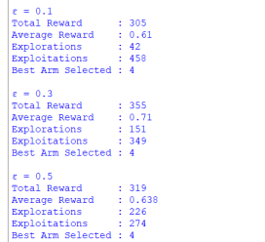
EXP 3: Design a Markov Decision Process (MDP) for an autonomous robot that must reach a destination while minimizing energy consumption. Define the states, actions, transition probabilities, rewards, and energy constraints.
CODE :
import random
# Grid size
GRID_SIZE = 4
# Start and Goal
start = (0, 0)
goal = (3, 3)
# Energy available
energy = 10
# Actions
actions = {
"UP": (-1, 0),
"DOWN": (1, 0),
"LEFT": (0, -1),
"RIGHT": (0, 1)
}
# Transition probabilities
# 80% move correctly, 20% stay in same place
success_probability = 0.8
state = start
total_reward = 0
print("Autonomous Robot MDP Simulation")
print("Start State:", state)
print("Goal State:", goal)
print("Initial Energy:", energy)
while state != goal and energy > 0:
action = random.choice(list(actions.keys()))
print("\nChosen Action:", action)
if random.random() < success_probability:
move = actions[action]
new_row = state[0] + move[0]
new_col = state[1] + move[1]
if 0 <= new_row < GRID_SIZE and 0 <= new_col < GRID_SIZE: state = (new_row, new_col)
energy -= 1
if state == goal:
reward = 100
else:
reward = -1
total_reward += reward
print("Current State:", state)
print("Reward:", reward)
print("Remaining Energy:", energy)
if state == goal:
print("\nRobot reached the destination!")
else:
print("\nRobot ran out of energy!")
print("Total Reward:", total_reward)
OUTPUT :
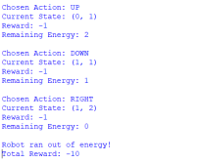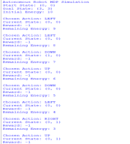
EXP 4 : Using Python and TensorFlow/Keras, implement a value iteration algorithm to determine the optimal policy for a constrained grid environment where certain states are restricted. Explain how Bellman equations are used to obtain the optimal policy.
CODE :
import numpy as np
grid_size = 4
gamma = 0.9
goal = (3, 3)
restricted = [(1, 1), (2, 2)]
values = np.zeros((grid_size, grid_size))
actions = [(-1,0),(1,0),(0,-1),(0,1)]
while True:
delta = 0
new_values = values.copy()
for i in range(grid_size):
for j in range(grid_size):
if (i, j) == goal:
continue
if (i, j) in restricted:
continue
best = -1000
for action in actions:
ni = i + action[0]
nj = j + action[1]
if ni < 0 or ni >= grid_size or nj < 0 or nj >= grid_size:
ni = i
nj = j
if (ni, nj) in restricted:
ni = i
nj = j
reward = -1
if (ni, nj) == goal:
reward = 10
value = reward + gamma * values[ni][nj]
if value > best:
best = value
new_values[i][j] = best
delta = max(delta, abs(values[i][j] - best))
values = new_values
if delta < 0.001:
break
print("Optimal State Values")
print(values)
print("\nOptimal Policy")
policy = [["" for j in range(grid_size)] for i in range(grid_size)] for i in range(grid_size):
for j in range(grid_size):
if (i, j) == goal:
policy[i][j] = "G"
continue
if (i, j) in restricted:
policy[i][j] = "X"
continue
best = -1000
move = ""
directions = {
"U":(-1,0),
"D":(1,0),
"L":(0,-1),
"R":(0,1)
}
for name, action in directions.items():
ni = i + action[0]
nj = j + action[1]
if ni < 0 or ni >= grid_size or nj < 0 or nj >= grid_size:
ni = i
nj = j
if (ni, nj) in restricted:
ni = i
nj = j
reward = -1
if (ni, nj) == goal:
reward = 10
value = reward + gamma * values[ni][nj]
if value > best:
best = value
move = name
policy[i][j] = move
for row in policy:
print(row)
OUTPUT :
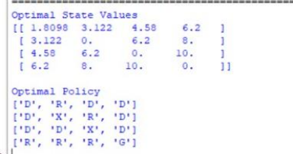
EXP 5 : A warehouse robot has a battery capacity of only 30 minutes. Design an RL framework that enables the robot to complete the maximum number of deliveries without exceeding the battery limit. Explain the constraints, policy, and reward design.
CODE :
import random
battery = 30
deliveries = 0
total_reward = 0
actions = ["Deliver", "Wait"]
print("Warehouse Robot Simulation")
print("Battery:", battery, "minutes")
while battery > 0:
action = random.choice(actions)
if action == "Deliver":
time_used = random.randint(3, 6)
if battery >= time_used:
battery -= time_used
deliveries += 1
total_reward += 10
print("Action : Deliver")
print("Time Used :", time_used)
print("Battery Left :", battery)
print("Reward : +10\n")
else:
print("Not enough battery for delivery")
break
else:
battery -= 1
total_reward -= 1
print("Action : Wait")
print("Battery Left :", battery)
print("Reward : -1\n")
print("Simulation Completed")
print("Total Deliveries :", deliveries)
print("Total Reward :", total_reward)
print("Battery Remaining :", battery)
OUTPUT :
